

**AMERICAN INTERNATIONAL UNIVERSITY–BANGLADESH (AIUB)**

**Faculty of Science and Technology**

**Department of Computer Science**

**Spring 2022-2023**

Course: **Introduction to Database**

Section : **[K]**

|  |
| --- |
| **“PHARMACY MANAGEMENT SYSTEM”** |

 **Submitted to : MD SAJID BIN- FAISAL**





|  |  |
| --- | --- |
| **NAME** | **ID** |
| **Mohammad Ansar Uddin** | **22-47975-2** |
| **Chinmoy Guha** | **22-48056-2** |
| **MD. Abdullah** | **22-48065-2** |
| **Suvra Chakraborty** | **22-48067-2** |



***TABLE OF CONTENTS:***

* **Introduction**
* **Scenario Description**
* **ER-Diagram**
* **Normalization**
* **Table Creation**
* **Data Insertion**
* **Query Writing**
* **Conclusion**

***INTRODUCTION:***

A pharmacy management system is designed to keep track of medicines and prescriptions in a pharmacy. The system stores information about the medicines, prescriptions, patients, pharmacists and medicine manufacturers making it easier for pharmacists to track inventory levels, monitor patient prescriptions, and manage the overall operation of the pharmacy. The system is designed to be user-friendly, with a simple interface that allows pharmacists to quickly and easily access the information they need, allowing them to be more efficient in their day to day tasks.   
  
We have planned out a scenario and created an ER-Diagram to help us visualize and draw out a structure of the database regarding all the necessary entities and relationships between them. Then we did normalization to identify the required tables of the database. In this report we have demonstrated the creation of those tables as well as a few important queries of the pharmacy management system.  
  
Overall, the pharmacy management system database is an invaluable tool for pharmacists and pharmacy owners alike, helping to ensure that medicines are dispensed safely and efficiently, and that patients receive the care they need to maintain their health.



***SCENARIO:***

A patient buys medicine from a Pharmacy. A patient is identified by patient ID, with name, address, and contact information. A Patient can buy many medicines and a medicine can be bought by many patients. Medicines are identified by medicine ID, with name, description, dosage, price and categories. It may be specialized into a syrup, tablets, injection. A patient may be in possession of a prescription. A patient may have many prescriptions. A prescription has exactly one patient. Prescriptions are identified by prescription ID, with date, duration. Medicines can be prescribed through the prescription. A prescription may contain many medicines. Medicine can be prescribed in many prescriptions. A pharmacist serves patients with prescriptions. Pharmacists are identified by pharmacist ID, with name and contact information. A pharmacist may dispense many prescriptions to patients and a patient with prescription may be dispensed by one pharmacist. Medicines are made by manufacturers. Manufacturers are identified by their names, IDs, contact information. A medicine may have many manufacturers, and a manufacturer may produce many medicines

***ER-DIAGRAM:***

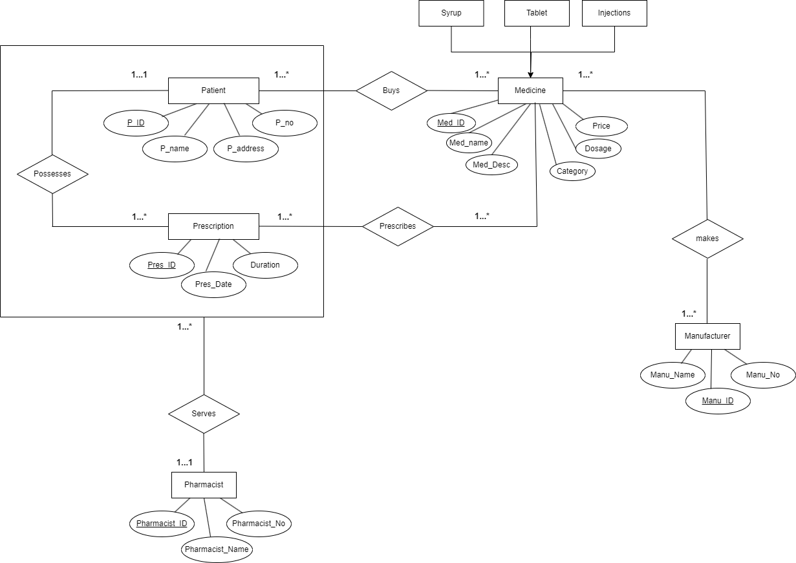

***NORMALIZATION:-***

UNF:

(buys): P_id, P_name, P_address, P_no, Med_id, category, Med_name, Med_desc, dosage, price

1NF: P_id, P_name, P_address, P_no, Med_id, category, Med_name, Med_desc, dosage, price

2NF: 1) P_id, P_name, P_address, P_no

2) Med_id, category, Med_name, Med_desc, dosage, price

3) P_id (Pk), Med_id (Fk)

3NF: Same as 2NF

UNF:

(Serves): P_id, P_name, P_address, P_no, Pres_ID, Pres_Date, Duration, pharmacist_id, pharmacist_no, pharmacist_name

1NF: P_id, P_name, P_address, P_no, Pres_ID, Pres_Date, Duration, pharmacist_id, pharmacist_no, pharmacist_name

2NF: 1) P_id (Fk), P_name, P_address, P_no, Pres_ID, Pres_Date, Duration,   
 pharmacist_id (Fk)

2) pharmacist_id, pharmacist_no, pharmacist_name

3NF: Same as 2NF

****UNF:

(Prescribes): Pres_ID, Pres_Date, Duration, category, Med_id, Med_name, Med_desc, price, dosage

1NF: Pres_ID, Pres_Date, Duration, category, Med_id, Med_name, Med_desc, price, dosage,

2NF: 1) Pres_ID, Pres_Date, Duration

2) category, Med_id, Med_name, Med_desc, price, dosage

3) Pres_ID (Pk), M_id (Fk)

3NF: Same as 2NF

UNF:

(possesses) : P_id, P_name, P_address, P_no, Pres_ID, Pres_date, duration

1NF : p_id, p_name, p_address, p_no, pres_id, pres_date, duration

2NF : 1) p_id, p_name ,p_address, p_no

2) pres_id (PK), pres_date, duration , P_id (FK)

3NF : Same as 2NF

UNF

(Makes) : Med_id, Med_name, Med_desc, dosage, price, category, manu_name, manu_no, manu_id

1NF : med_id, med_name, med_desc, dosage, price, category, manu_name, manu_no, manu_id

2NF : 1) med_id, med_name, med_desc, dosage, price, category

2) manu_name, manu_no, manu_id

3) Med_id (Pk), manu_id (Fk)  
 3NF : Same as 2NF

***Finalization***

1) P_id, P_name, P_address, P_no (Name of table: Patient)

2) Med_id, category, med_name, med_desc, dosage, price (Name of table: Medicine)

3) P_id (Pk), Med_id (Fk) (Name of table: Buy)

4) P_id (Fk), P_name, P_address, P_no, Pres_ID, Pres_Date, Duration, pharmacist_id (Fk)  
 (Name of table: Serve)

5) pharmacist_id, pharmacist_no, pharmacist_name (Name of table: Pharmacist)

6) Pres_ID, Pres_Date, Duration (Name of table: Prescription)

7) Pres_ID (Pk), Med_id (Fk) (Name of table: Prescribe)

8) manu-name, manu-no, manu-id (Name of table: Manufacturer)

9) med_id (Pk), manu_id (Fk) (Name of table: Make)

10) pres_id (PK), pres_date, duration, P_id (FK) (Name of table: Possess)

***TABLE CREATION:-***

* In total there are 10 tables created.
* create table PATIENT (P_ID number(4) primary key, P_NAME varchar(100), P_ADDRESS VARCHAR(100), P_NO number(11))

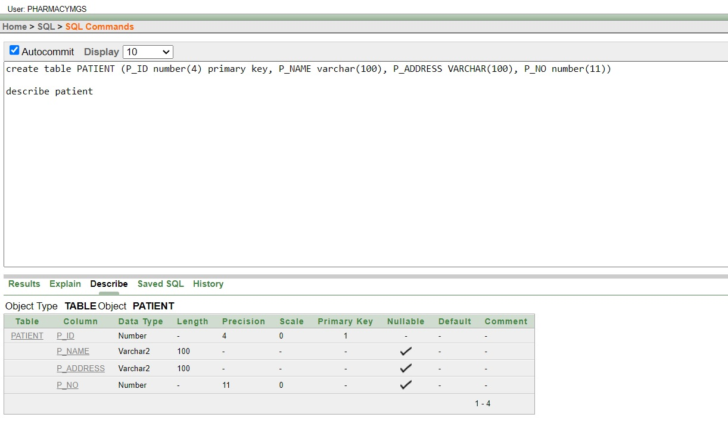

* create table MEDICINE (MED_ID number(3) primary key, MED_NAME varchar(100), CATEGORY varchar(100), MED_DESC varchar(100), DOSAGE varchar(100), PRICE number(3))

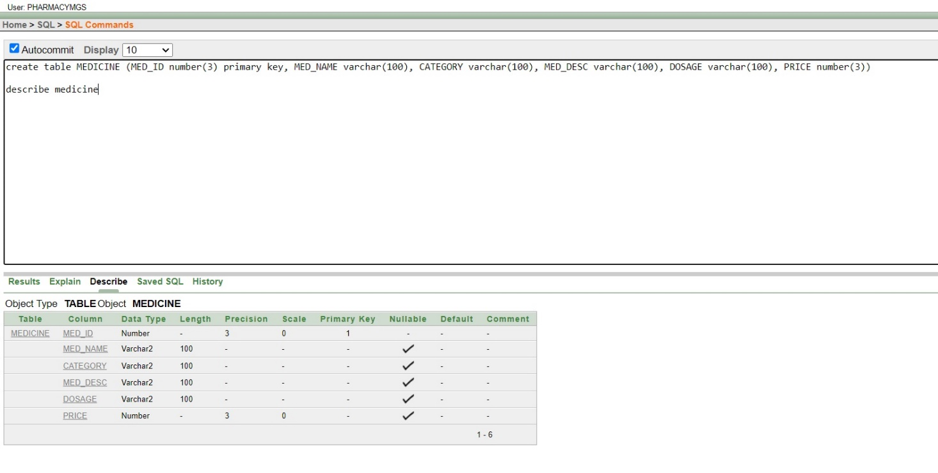

* create table BUY (P_ID number(4) primary key, MED_ID number(3))

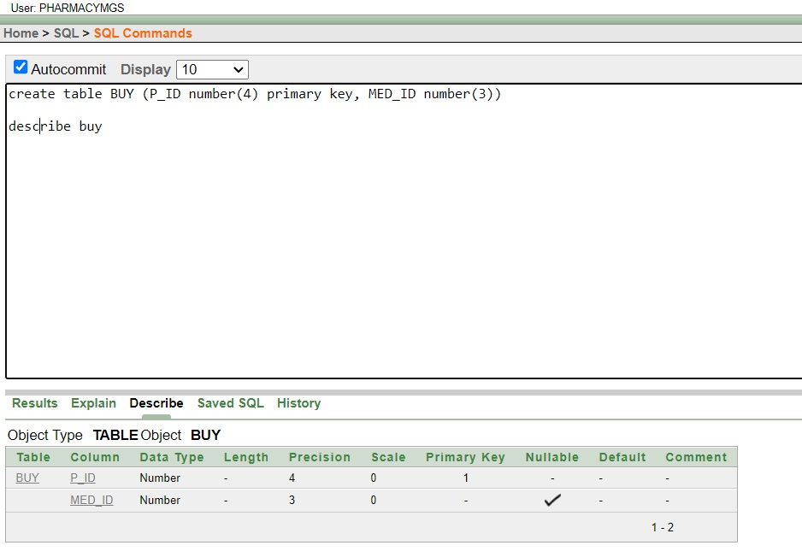

* 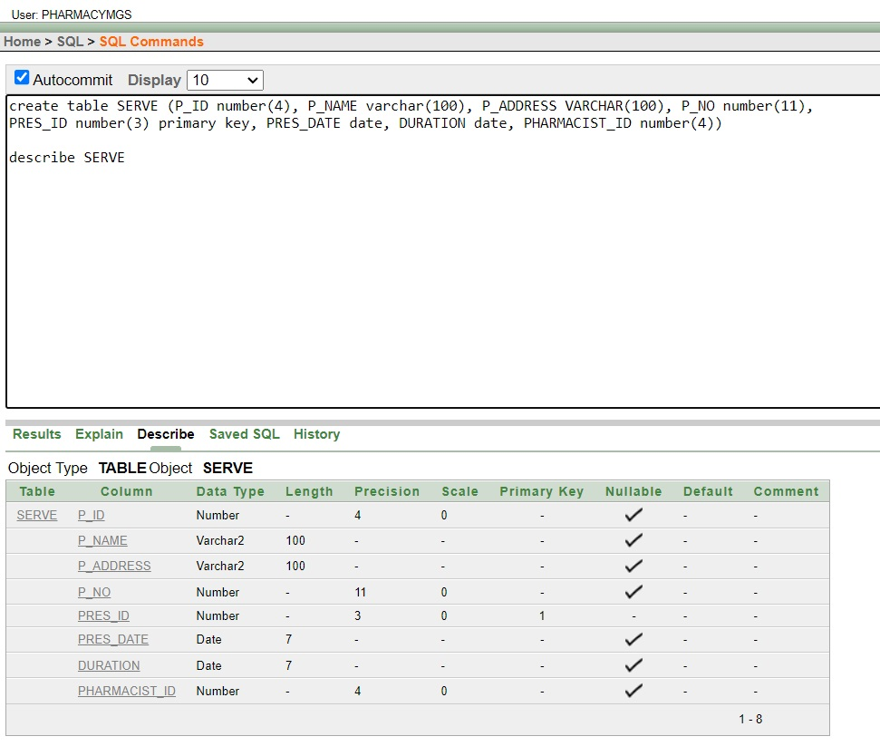create table SERVE (P_ID number(4), P_NAME varchar(100), P_ADDRESS VARCHAR(100), P_NO number(11), PRES_ID number(3) primary key, PRES_DATE date, DURATION date, PHARMACIST_ID number(4))
* create table PHARMACIST (PHARMACIST_ID number(4) primary key, PHARMACIST_NO number(11), PHARMACIST_NAME varchar(100))

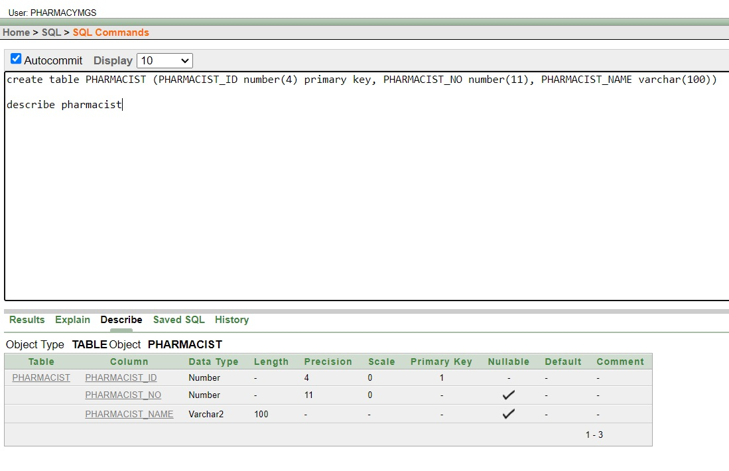

* 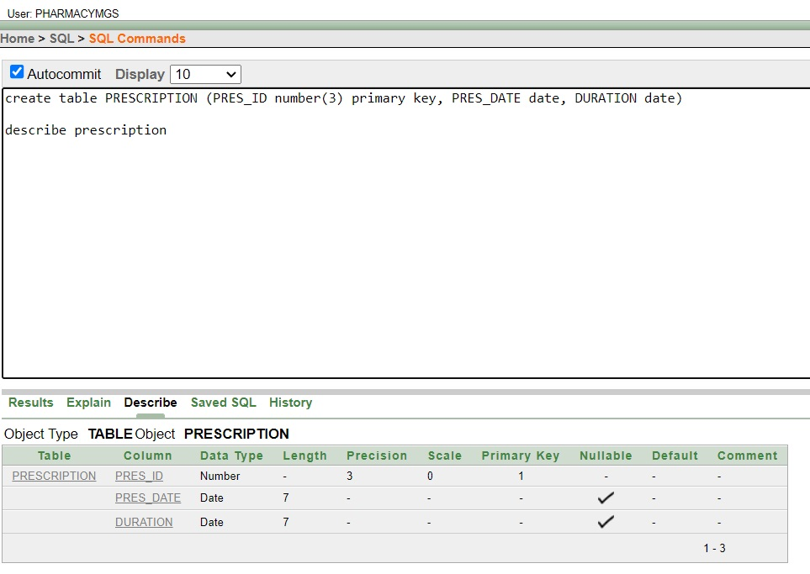create table PRESCRIPTION (PRES_ID number(3) primary key, PRES_DATE date, DURATION date)

* create table PRESCRIBE (PRES_ID number(3) primary key, MED_ID number(3))

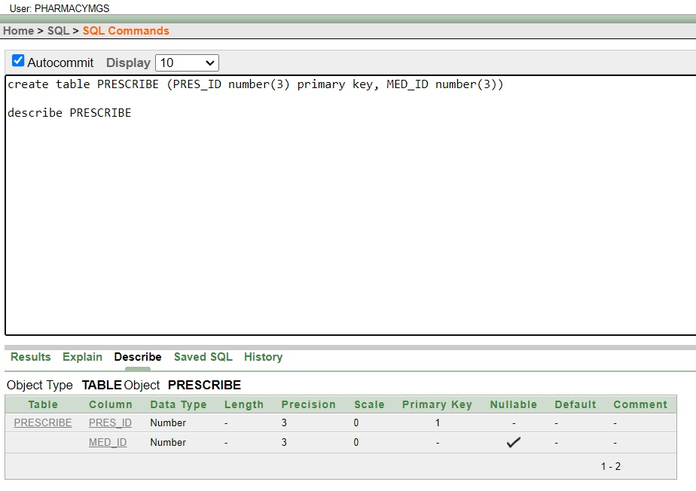

* 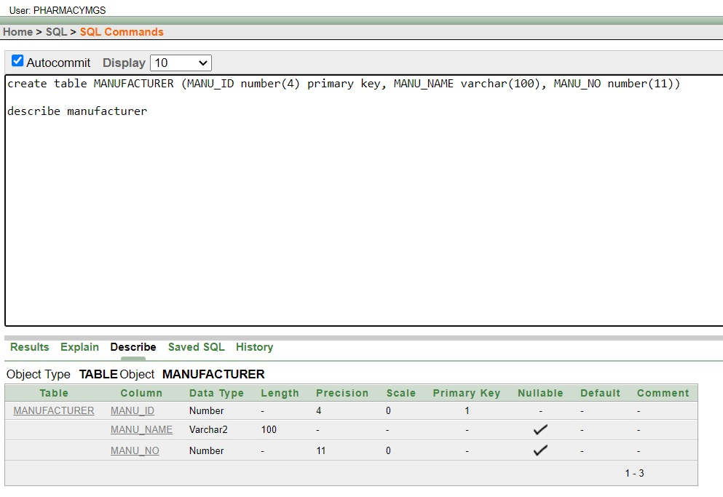create table MANUFACTURER (MANU_ID number(4) primary key, MANU_NAME varchar(100), MANU_NO number(11))
* 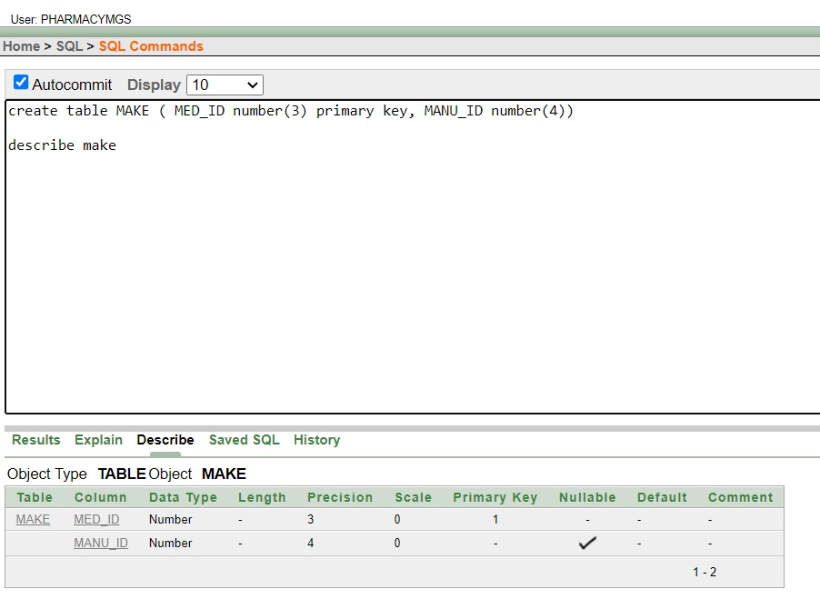create table MAKE ( MED_ID number(3) primary key, MANU_ID number(4))
* create table POSSESS (PRES_ID number(3) primary key, PRES_DATE date, DURATION date, P_ID number(4))

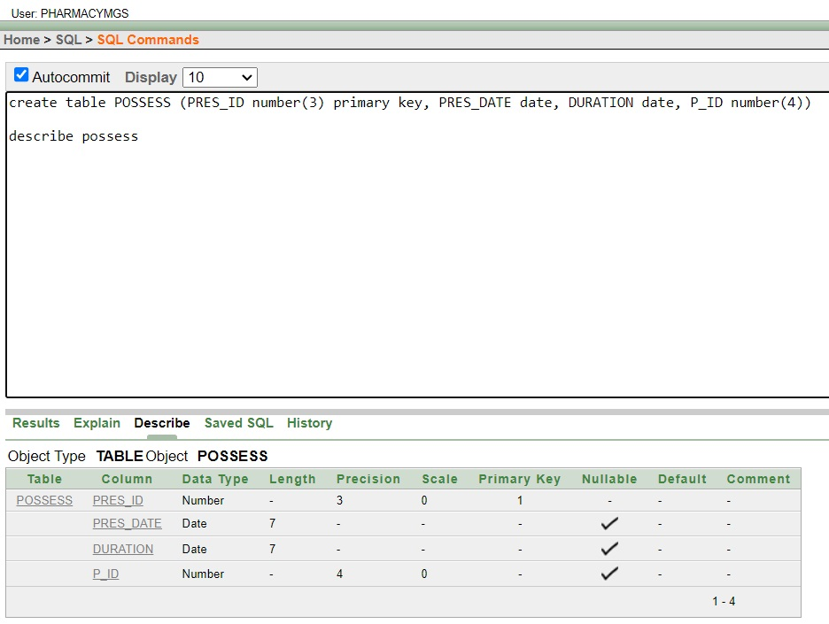

***DATA INSERTION:***

**PATIENT-**

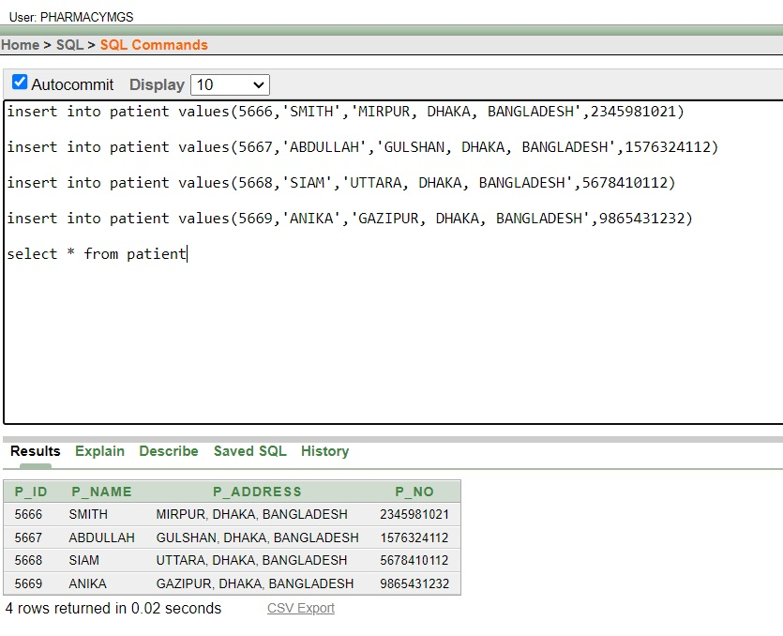

**MEDICINE-*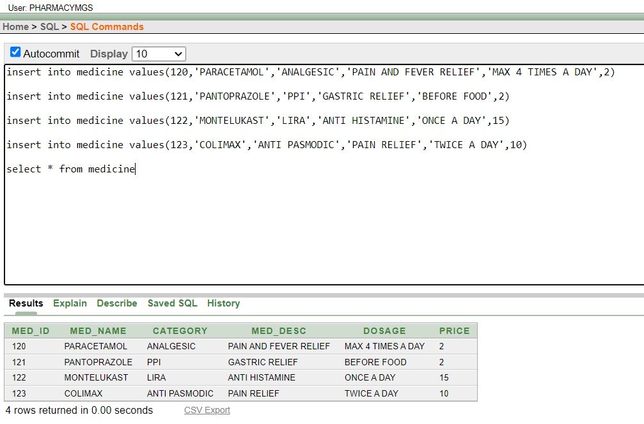***

**BUY-**

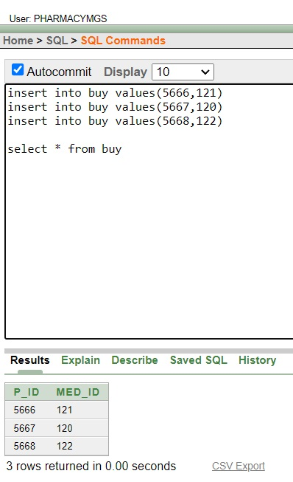

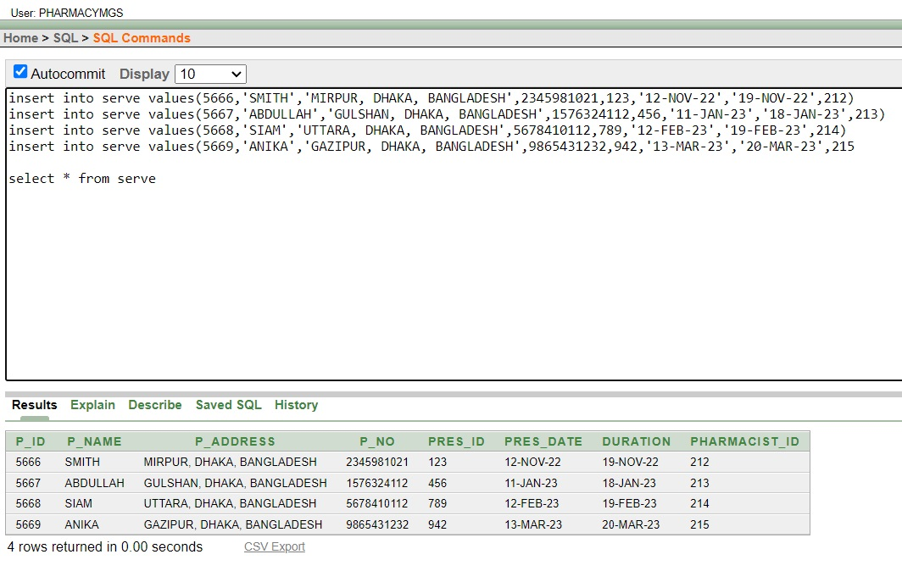**SERVE-**

**PHARMACIST-**

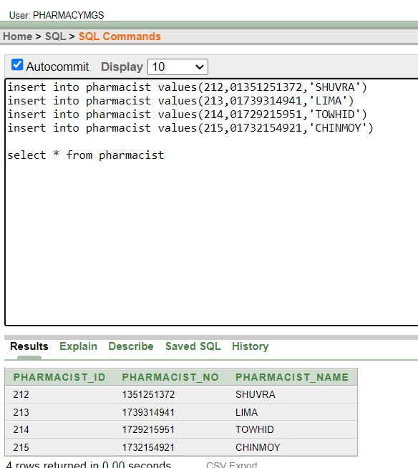

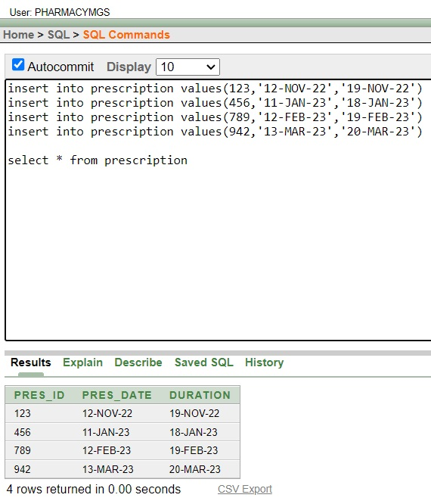**PRESCRIPTION-**

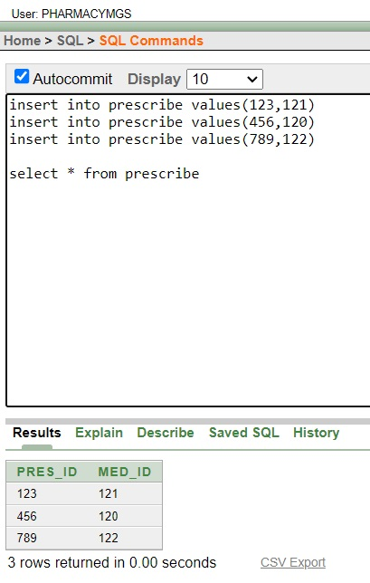**PRESCRIBE-**

**MANUFACTURER-**

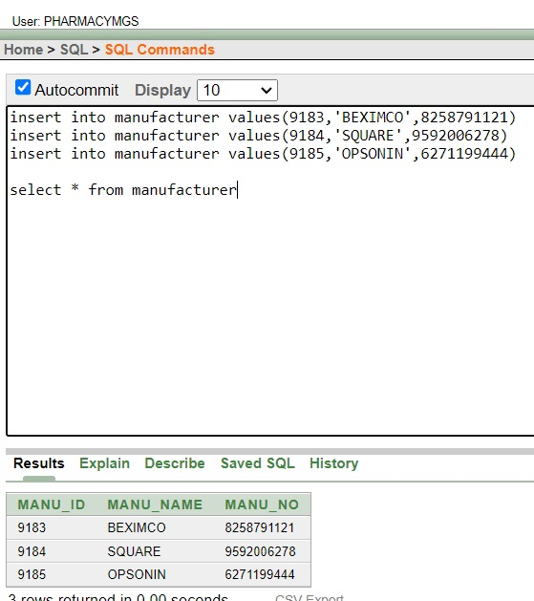

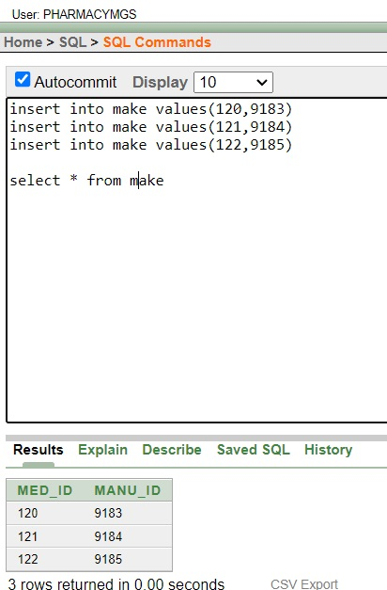**MAKE-**

**POSSESS-**

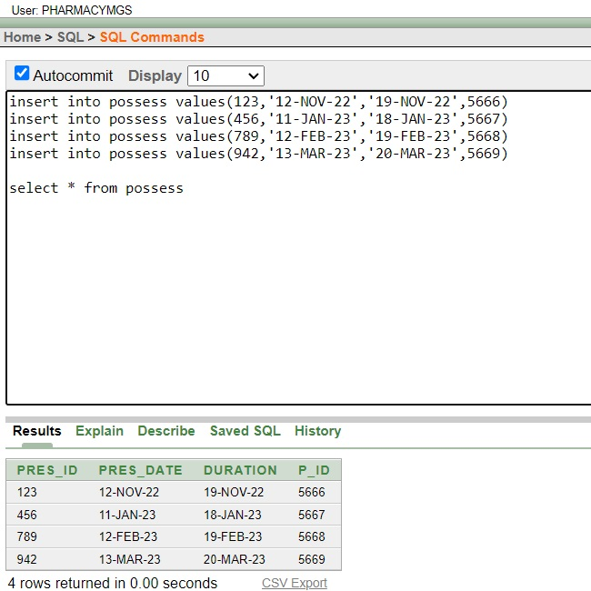

***QUERIES:-***

**Single Row:**

1. **Find the p_id, p_name, and pres_id of all records in the serve table where the pres_id is less than or equal to the pres_id of the record where pharmacist_id is equal to 212:**

* select p_id, p_name, pres_id from serve where pres_id <= (select pres_id from serve where pharmacist_id = 212)

**Figure**: Command of query

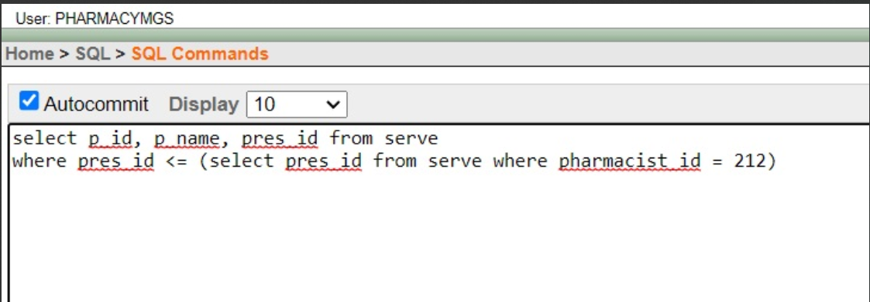

**Figure**: Result of query

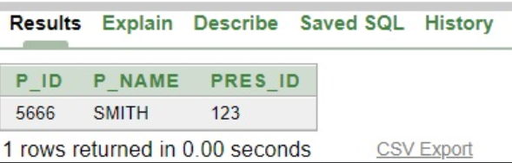

1. **Find the med_name, category, and price of all records in the medicine table where the med_id is greater than the med_id of the record where med_name is 'PARACETAMOL' and the price is equal to the price of the record where category is 'LIRA':**

* select med_name, category, price from medicine where med_id > (select med_id from medicine where MED_NAME = 'PARACETAMOL') AND price = (select price from medicine where category = 'LIRA')

**Figure**: Command of query

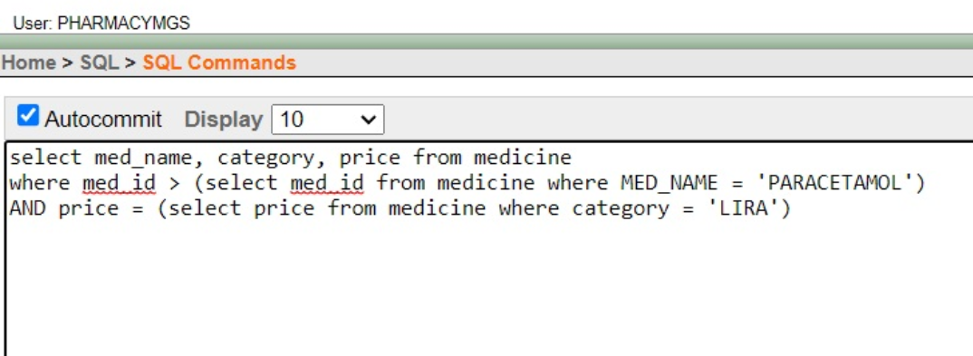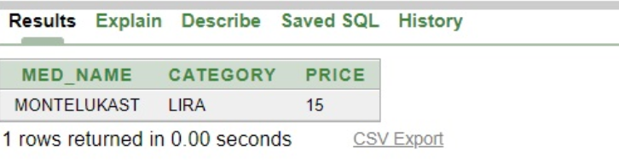

**Figure**: Result of query



**Multiple Row**

1. **Find the p_name and p_address of all records in the patient table where the p_id is greater than all the p_id values in the subquery that selects p_id values where p_no is equal to 2345981021:**

* select P_name, p_address from patient where p_id > all ( select p_id from patient where p_no = 2345981021)

**Figure**: Command of query

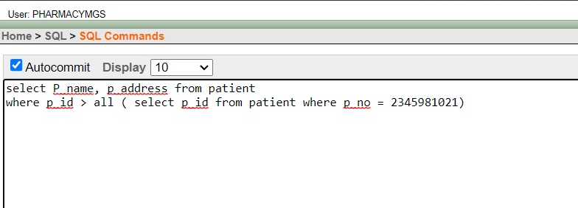

**Figure**: Result of query

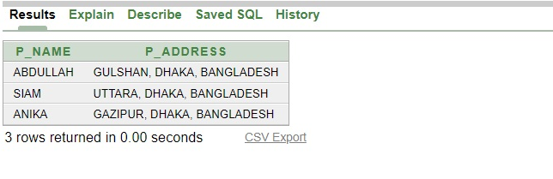

1. **Find the p_id, p_name, and pres_id of all records in the serve table where the pres_id is greater than any of the pres_id values in the subquery that selects pres_id values where pharmacist_id is equal to 212:**

* select p_id, p_name, pres_id from serve where pres_id > any (select pres_id from serve where pharmacist_id = 212)

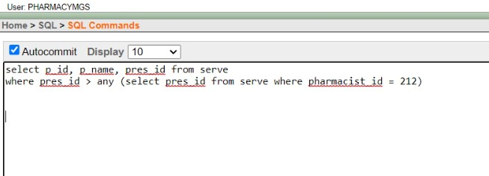**Figure**: Command of query

**Figure**: Result of query

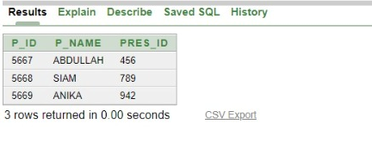

**Joining**

Equijoin-

**Find the p_name, p_id, pres_id, and pres_date of all records in the patient and serve tables where the p_id values match:**

* select pat.p_name, pat.p_id, s.p_id, s.pres_id, s.pres_date from patient pat, serve s where pat.p_id = s.p_id

**Figure**: Command of query

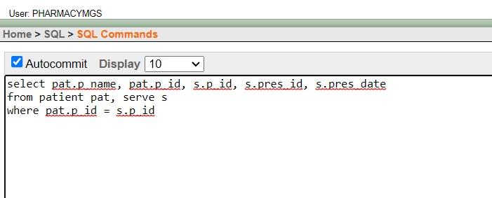

**Figure**: Result of query

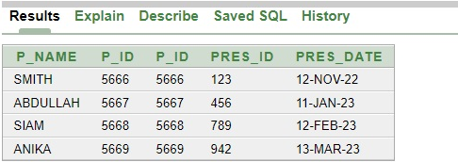

Outer Join-

**Find the med_name, med_id, and corresponding buy.med_id of all records in the medicine and buy tables, including records where there is no matching buy.med_id value:**

* select m.med_name, m.med_id, b.med_id from medicine m, buy b where m.med_id = b.med_id(+)

**Figure**: Command of query

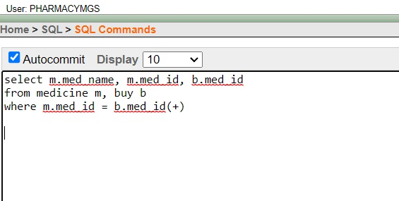

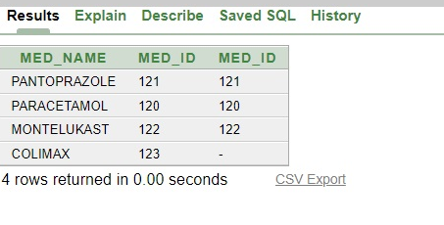**Figure**: Result of query

**Aggregate function:**

**Find the maximum p_id value of all records in the serve table where the p_name value contains the letter 'S':**

* select max(p_id) from serve where p_name like '%S%'

**Figure**: Command of query

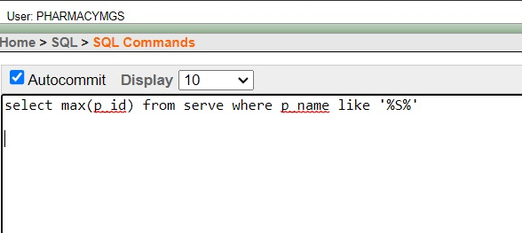

**Figure**: Result of query

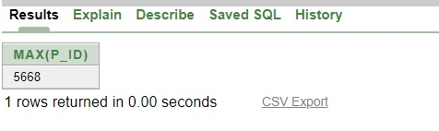

**View:**

**Simple view-**

**->A view is created for the medicine details where the price of the medicine is 2 tk**

**Figure**: Command of View

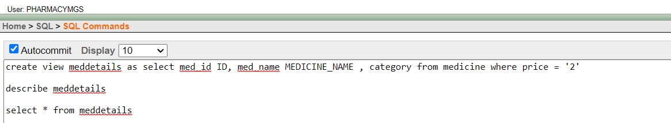

**Figure**: Description of View

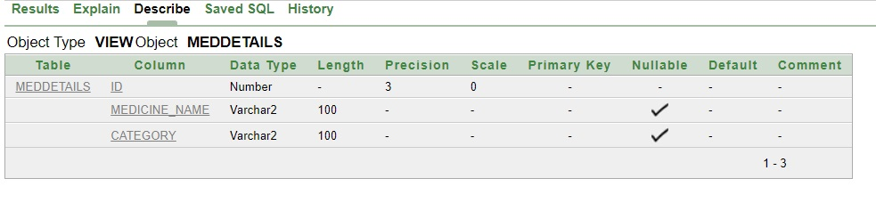

**Figure**: The View Table

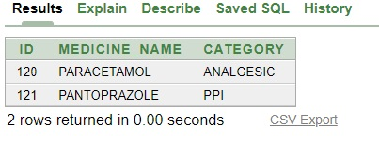

***CONCLUSION:-***

* In conclusion, the Pharmacy Management System is an essential database project for efficient and organized management of a pharmacy. By implementing this system, several benefits can be achieved. Firstly, it simplifies inventory management by keeping track of available medicines, their quantities, and expiration dates. This helps prevent stockouts and reduces wastage. Secondly, it streamlines the sales process by automating billing and generating accurate invoices. This improves customer service and reduces errors. Thirdly, it facilitates prescription management by storing patient information, medication history, and dosage instructions. This enables quick retrieval of records and enhances patient safety. Additionally, the system aids in tracking supplier information, purchasing history, and pricing details, ensuring seamless procurement of medicines. It also supports comprehensive reporting and analysis, enabling data-driven decision-making for business growth. There are further ways to improve it as well:
* Implement Alerts and Notifications: Introduce automated alerts and notifications for low stock levels, upcoming medication expirations, and prescription refills. This ensures proactive management and prevents stockouts or expired products.
* Online Ordering and E-Prescriptions: Enable online ordering for customers and integration with electronic prescription systems. This allows for convenient ordering and reduces paperwork, while also improving accuracy and efficiency.
* Integration with Accounting Systems: Integrate the pharmacy management system with accounting software to automate financial processes, such as invoicing, payments, and expense tracking. This improves accuracy and saves time on manual bookkeeping tasks.
* Mobile App Development: Develop a mobile application for the pharmacy management system, allowing users to access information and perform tasks on the go. This provides convenience and flexibility for both staff and customers.
* Data Security and Backup: Implement robust security measures to protect sensitive patient and business data. Regularly backup the database to prevent data loss in case of system failures or emergencies.

Overall, the Pharmacy Management System optimizes operations, enhances customer satisfaction, and improves the overall efficiency of the pharmacy.